

PAKISTAN INSTITUTE OF ENGINEERING AND APPLIED SCIENCES

***Computing Fundamentals & Programming***

**FALL 2020**

**ATM with Functions**

**Department: Physics**

**Name: Umar Shifaqat**

**Serial No. 43**

**Roll No. BS-20-GB-100864**

**Date: DECEMBER 23, 2020**

**ATM FUNCTIONS**

**C-Code to develop an ATM machine using Functions.**

**INPUT**

#include<stdio.h>

#include<conio.h>

#include<stdlib.h>

int balance=100000;

int PIN=7890;

void PIN_check(void);

void balance_enquiry(void);

void cash_withdraw(void);

void cash_deposit(void);

void pin_change(void);

void Exit();

void main()

{

int func;

puts("\n\t\t\t**** WELCOME TO HABIB BANK, LIMITED *****");

PIN_check();

while(2)

{

printf("\n\tWhat do you want to do : \n\t 1. BALANCE ENQUIRY\n\t 2. CASH WITHDRAWAL ");

printf("\n\t 3. CASH DEPOSIT \n\t 4. CHANGE PIN NUMBER \n\t 5. EXIT\n\n\tChoice: ");

scanf("%d",&func);

switch(func)

{

case 1:

balance_enquiry();

break;

case 2:

cash_withdraw();

break;

case 3:

cash_deposit();

break;

case 4:

pin_change();

break;

case 5:

Exit();

default:

puts("\a\n\t\t!!!>> Invalid choice <<!!!\n");

}

}

}

void PIN_check(void)

{

int i=0,pin;

do

{

if(i==3)

{

printf("\a\n\t\tYou have Entered wrong PIN 3 times.Your card is captured. Please contact the Bank Manager.");

getch();

exit(9);

}

printf("\t\tPlease enter your 4 digit PIN CODE in the form of XXXX\n\n\t\t\t>>> PIN : ");

scanf("%d",&pin);

if(pin!=PIN)

printf("\a\n\n\t\t\t\t << You have entered Wrong PIN >>\n");

i++;

} while(pin!=PIN);

}

void balance_enquiry(void)

{

printf("\n \t\t******\t Your Current Balance is Rs/ %d=\t******\n",balance);

}

void cash_withdraw(void)

{

int withdraw,opt;

puts("\n\tPlease Enter the Amount to Withdraw");

puts("\tNote:\(You can Withdraw a Maximum of Rs /10,000= in Multiples of Rs/ 500= only\)");

do

{

printf("\n\t\t\t>> \"Amount\" : ");

scanf("%d",&withdraw);

if(withdraw<0)

{puts("Please Enter a Valid Amount\a");continue;}

else if(withdraw>balance)

{printf("\a\n\t\t Entered Amount is more than Current Balance in Your Account.\n"); break;}

else if(withdraw%500!=0)

{printf("\a\n\t\tPlease enter an amount in Multiples of Rs/500= "); continue;}

else if (withdraw>10000)

{printf("\a\n\t\tPlease enter an Amount less than Rs\ 10,000="); continue;}

balance-=withdraw;

printf("\n\t\tPlease Take Your Amount\n");

balance_enquiry();

printf("\n\tDo you want more transaction?\n\t 1. Yes \n\t 2. No \n\tchoice: ");

scanf("%d",&opt);

}while(opt!=2);

}

void cash_deposit(void)

{

int deposit;

while(2)

{

puts("\n\t\tPlease Enter amout to deposit in multiples of Rs/500= ");

printf("\t\t\t\t\"Deposit Amount\" : ");

scanf("%d",&deposit);

if(deposit%500==0)

{

balance+=deposit;

balance_enquiry();

break;

}

if(deposit<0)

{

puts("Please Enter a Valid Amount\a");

continue;

}

printf("\a\n\t\tYou have Deposited Amount which is not Multiple of Rs/500= ");

}

}

void pin_change(void)

{

int old_pin,pin1,pin2;

while(2)

{

printf("\n\t\tPlease enter the old PIN:");

scanf("%d",&old_pin);

if(PIN==old_pin)

break;

printf("\a\t\t Wrong PIN entered!\n");

}

do

{

printf("\n\t\tEnter the New PIN code twice:\n\t\tNEW PIN: ");

scanf("%d",&pin1);

if(pin1>9999||pin1<1000)

{puts("\aPlease enter a 4 Digit PIN"); continue; }

printf("\t\tRe-Enter NEW PIN: ");

scanf("%d",&pin2);

(pin1!=pin2)?printf("\a\n\t\tEntered PIN codes donot match"):PIN=pin1;

}while(pin1!=pin2);

}

void Exit()

{

printf("\n\n\n\t\t\t ******** <<< Thanks. Allah Hafiz >>> ******** \n\n\t\t\t __________ Please Take Your Card ___________\n");

getche();

exit(0);

}

**OUTPUT**

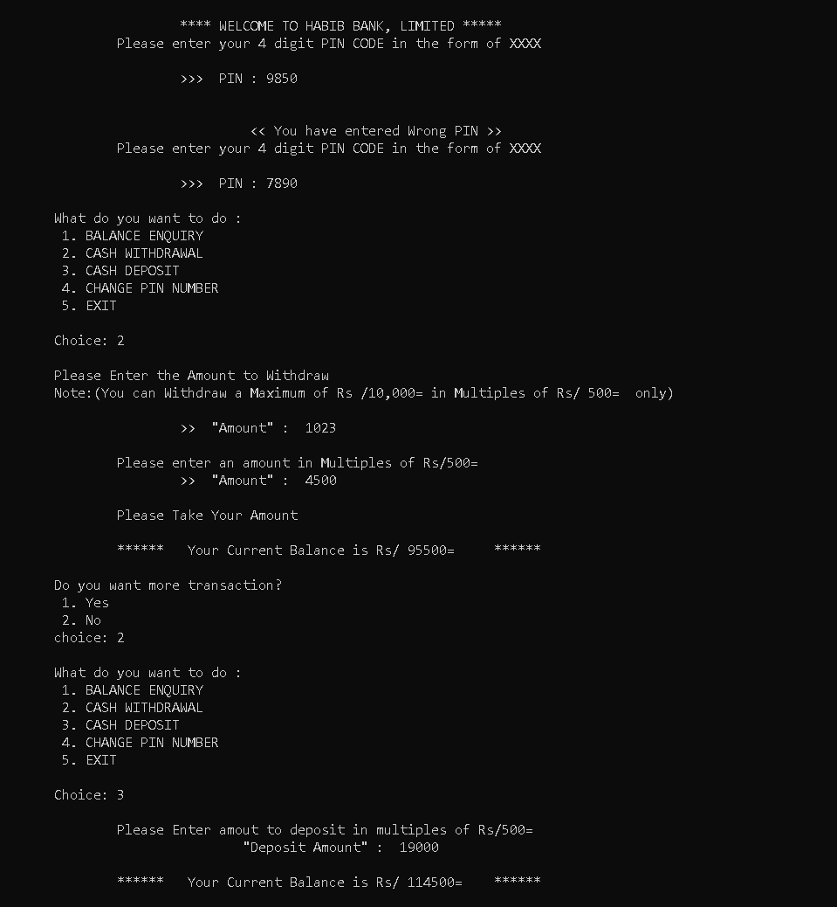

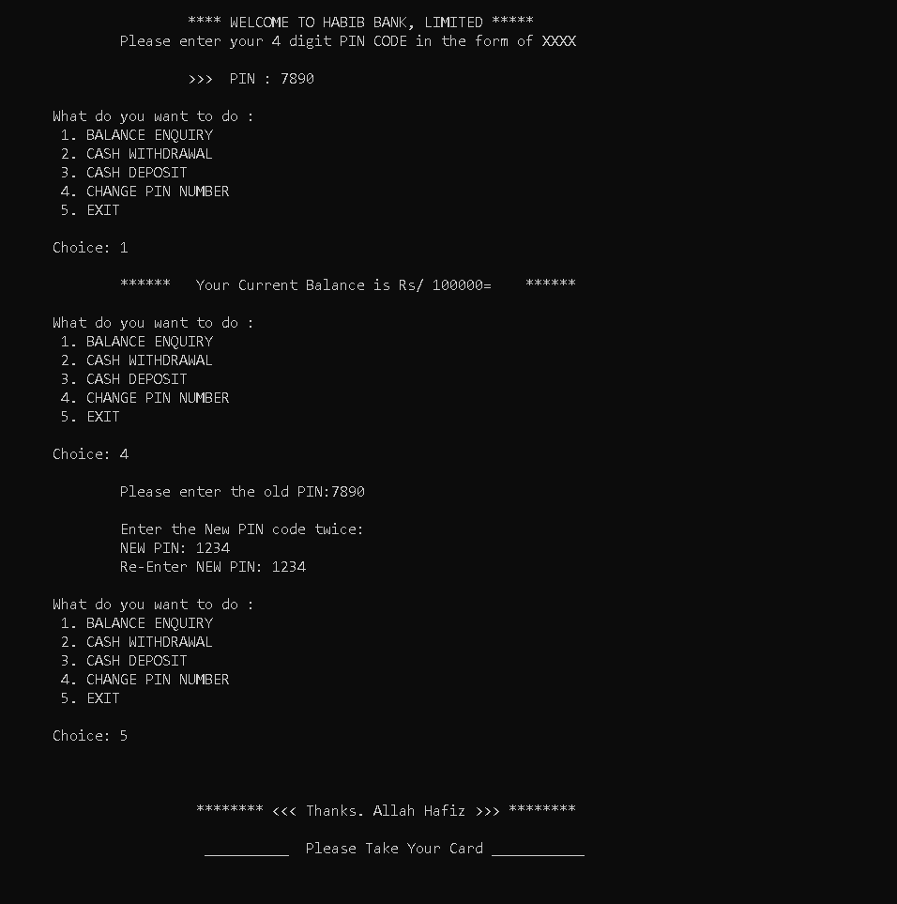

THE END